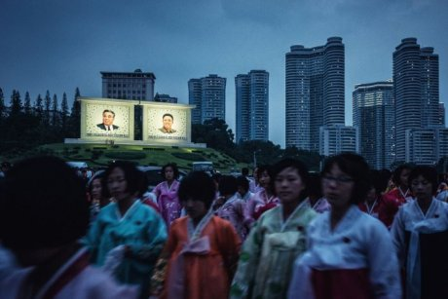
North Korean defectors studying in Sydney recall first time using the internet and tasting cookies
The World Today By Stephen Smiley
North Korean women gather in front of billboards of Kim Il-Sung and Kim Jong-Il.When Jayden first fled North Korea five years ago, nothing could have prepared him for the internet. Despite sharing the same language and with their capitals barely 200 kilometres apart, a world divides the two nations on the Korean peninsula.
For Jayden, it was the vast amounts of freely available information that came as a particular shock. Coming from a nation with no free media — let alone unfettered access to the internet — to one with some of the world's fastest connection speeds, Jayden's eyes were opened.
"The first time I had the opportunity to access the internet, I saw so many internet news, and I wondered, is it true?," he says. "There is extreme limitation to access the information. When I was out of North Korea, the information overflowed. "And then I started thinking, 'Ah, this makes sense'."
One of a growing number of defectors from the totalitarian regime to have made it to safety across the border, Jayden must now adjust to his new life in Seoul, where later this year he will begin university.
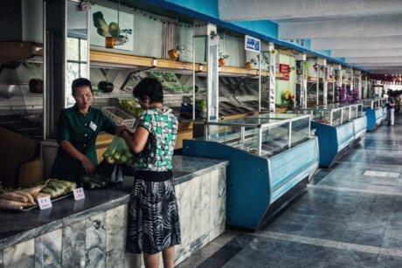
A North Korean woman buys groceries from an almost empty store.
"I knew there were some people suffering from starving or pain [in North Korea], but when I was young I never really thought very seriously, and then later I was kind of brainwashed from government," Jayden says.
But for now, he's one of a handful of former North Koreans spending the winter in Sydney, where he is learning English. He said there are two kinds of North Korean, those who understand that much of the official information fed to them by state media is curated and censored, and those who do not.

Childhoods of hunger and fear
It was a long journey to Sydney for Jayden's classmate, Ann, who defected from North Korea when she was 14 years old. Now 25, she says the clean Australian air is a sweet reminder of the freedoms she was deprived as a child growing up north of the demilitarised zone.
Ann grew up in the frozen hill country of northern North Korea, born into a poor but not destitute family in the years before a terrible famine — known in Korean as "The Arduous March" — devastated the country.
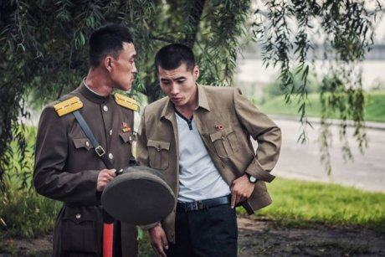

Photo Two North Korean soldiers confer outdoors.
As a young child, she remembers being cold and hungry, and recalls many absences at her primary school when her peers were too weak from hunger to attend class. "It was the hardest, hardest time of all history," she says. "Many people died from the starving, and when I went to the school there was a lot of students absent because they had no food."
One of Ann's happiest memories of growing up in North Korea is the day the United Nations World Food Program delivered supplies to her hunger-stricken town. "I remember the taste of the cookies, that was the happiest memory of my childhood," she says. 'I'm enjoying every single day'
Ann's story is not unique. Living in South Korea now she is part of a growing community of more than 30,000 defectors who have made lives for themselves south of the 38th parallel.
They share stories of hardship, hunger and discomfort, but there is nostalgia too among them.

Escape from the North
Ann, Jayden and three other students, whose real names the ABC is not using for security reasons, are in Sydney as part of a scholarship program for former North Koreans now living in the south. Five were selected through a competitive application process run by the South Korean Ministry of Unification and the Hana Foundation.
The students are completing an intensive English language class at the University of Technology, Sydney, co-sponsored by the Australian Government.
They are the second group of North Koreans to arrive in Australia for the class, after a successful pilot group last year.
"I'm enjoying every single day, this is the land of freedom. Already I can see my English is improving," Ann says.
The students say while life is much better in South Korea, it is not without its own struggles as they adapt to the pressures of a competitive, connected society.

From hunger to ambition
Associate Professor Bronwen Dalton, from the University of Technology, Sydney, helped get the North Korean scholarship program off the ground.
She says the students have been bowled over by the freedom and multiculturalism of Sydney, and will return to South Korea full of praise.
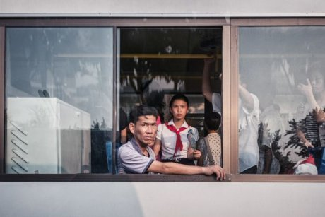

Photo A North Korean man through the window of a bus.
Facebook: Michal Huniewicz
"They go back and I have no doubt will be leaders in the Korean community," she said
"We are really training up the leaders of tomorrow, and the type of leaders that are always going to put Australia right at the top in terms of international relations."
Ann already has that kind of ambition. After her experiences of hunger during the North Korean famine, she says she wants to work in global aid.
"All around the world there is a lot of children who are starving," Ann says.
"I want to work in the World Food Program. That's why I'm learning English, to be the person who can help someone who needs."
The students will be in Sydney for another 22 weeks, before returning to Seoul to start university.

